ICSI404 – Assignment 6 – Cache

Introduction
So far, our processor doesn’t measure time at all. One of the most important parts of improving a CPU design is measuring, changing the design, and measuring again – this is the Scientific Method in action!
Clock speed is somewhat irrelevant, believe it or not. We want to measure the number of clock cycles that an instruction takes.
We will use some simple numbers – 300 cycles to access memory, 10 cycles for multiplication, 2 for addition/subtractions/other ALU functions. Register accesses are “free”. The attentive reader will immediately jump to the fact that every instruction needs to be read into memory, and therefore, every instruction will require more than 300 cycles. That is absolutely true!
A cache is a small amount of memory (SRAM) that is close to the CPU and much faster than main memory. Our caches are made up of lines – an address and 8 data items. If the address is X, the data items are *X, *(X+1), *(X+2) … *(X+7). We will implement a few different caches to improve our performance numbers.
Latency – No Cache | Instruction | Data
Main Memory | 300 | 300

Details
Create a “current clock cycle” integer in your processor, starting at 0. Add to it, using the numbers mentioned above. When your processor halts, print out the clock cycle. Measure the programs mentioned in “Testing” and record those values.
Latency – IC Only | Instruction | Data
In Instruction Cache | 10 | N/A
Main Memory | 350 | 300
Create a new InstructionCache class. This class will have a similar “read” method signature as MainMemory. It will implement a line – it will hold 8 words, plus an additional word – the address represented by the first of these 8 words. When a read happens, if the address that is read is in the cache, return the result. If the address is NOT in the cache, fill the cache (all 8 words) from main memory so that the address IS in the cache. Then return the result. A cache hit takes 10 clock cycles. A cache miss takes 350 clock cycles (10 to check the cache, then 340 to go out to memory, fill the cache and return the answer). 350 might seem odd – it takes only a little bit longer to get 8 words from main memory as it does to get 1? Yes, it does – it happens in parallel.
Update the current clock cycle code to accurately track this.
Change your Processor class, when loading instructions, to read from the instruction cache instead.
If you run some of your sample programs, you will now see that the cycle count is MUCH lower. Measure the programs mentioned in “Testing” and record those values. But we can easily see that this could be “gamed” to be less useful. Consider a loop that is 9 instructions long – we would replace the cache twice per iteration. Of course, we can “fix” this by making our cache bigger, but there is a trade-off – the bigger the cache, the slower it is. The solution is to make more caches, increasing in size, but decreasing in speed.
Latency – IC & L2 | Instruction
In Instruction Cache | 10
In L2 | 30
Main Memory | 370
Create an L2 cache. This cache will be 4 cache lines in size. Accessing this cache will cost 20 clock cycles; filling one of the groups of 8 Words will still require 340 clock cycles. Connect this to your InstructionCache so that an InstructionCache miss goes through L2. When an instruction is in L2, but not the InstructionCache, we can fill the InstructionCache from L2 for a total cost of 30 cycles. Measure the programs mentioned in “Testing” and record those values.
Latency – IC & L2 | Instruction | Data
In Instruction Cache | 10 | N/A
In L2 | 30 | 20
Main Memory | 370 | 360
Finally, change your load/store implementations so that instead of accessing main memory directly, they access L2 (we won’t have an L1 data cache). That will mean implementing Write() for L2. Use a write-through cache mechanism but make the cost for both read/write of data 20 cycles if the address is in cache, 360, otherwise.
Measure the programs mentioned in “Testing” and record those values.

Testing
There are two aspects to testing this assignment – one is making sure that your caches work. The second is testing some programs to measure performance, to see the benefits of the caches.
Write some assembly programs:
- Sum the numbers from 1-100 in a loop (no using Gauss’ (n(n+1))/2 formula)
- Create an array in memory of 100 integers. Then loop over then and sum them.
- Create a linked list of 100 integers. Loop over them and sum them.

You might ask “how do I allocate memory?” The answer is you don’t! The whole machine is yours. You can use any address that you want, so long as you make sure not to overwrite your program. Anything between 200 and 800 should be safe, unless your program gets very big OR you use a lot of recursion.
Write a short (one page, max) report that includes your results. The style should be similar to what you might have done in a science lab. Don’t use AI for this (spell/grammar checking is OK).

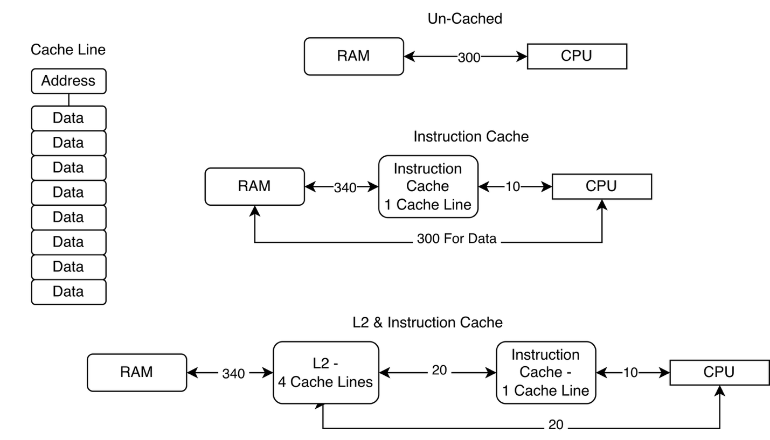

Checklist Before Submission
I am submitting only .java files. Other files will be ignored.
I am submitting all of the files that are necessary to build and grade.
My project builds
I did not copy another student’s work (or my own from a previous semester)
I did not use AI to generate this code.
If applicable, all of my bugs from previous assignments are fixed.

Rubric | Poor | OK | Good | Great
Code Style | Few comments, bad names (0) | Some good naming, some necessary comments (3) | Mostly good naming, most necessary comments (6) | Good naming, non-trivial methods well commented, static only when necessary, private members (10)
Cycle Count | None (0) |  |  | Works for multiplication, ALU (5)
InstructionCache | None (0) |  |  | Sized correctly, updates cycle count, refills from L2 (10)
L2 | None (0) |  |  | Sized correctly, updates cycle count, refills from L2 (10)
Integration into Processor | None (0) |  |  | Both instruction and data paths go through caches (10)
Sum Integers No Memory Test Program | None (0) |  |  | Works correctly (5)
Linked List Test Program | None (0) |  |  | Works correctly (15)
Sum Integers Memory Test Program | None (0) |  |  | Works correctly (15)
Report | None (0) |  |  | Appropriate tone/style, results are reasonable (20)

